|  |  |  |  |  |  |
| --- | --- | --- | --- | --- | --- |
| Date | 6-Sep-22 | | | Tester Name | Mohammad Yusuf |
| Environment | Penfax - Test | | | Login used |  |
| Operating System | Select OS | Version: | Update: | | |
| Software Used | Select Software | Version: | Update: | | |
| Select Software | Version: | Update: | | |
| Release version |  | | | | |
| Title | M17 Contributions & DCT | | | | |
| Test Type | Regression | | | | |
| Test Scenario | M17.07 Creating an Address Change File | | | | |
|  |  | | | | |
| Expected Results | Address should be updated under Person Summary and Contact Information. | | | | |
| Pass/Fail | Pass | | | JIRA# | N/A |

Describe your steps with screenshots:

1. Bring up an active MEPP member whose address you want to change.

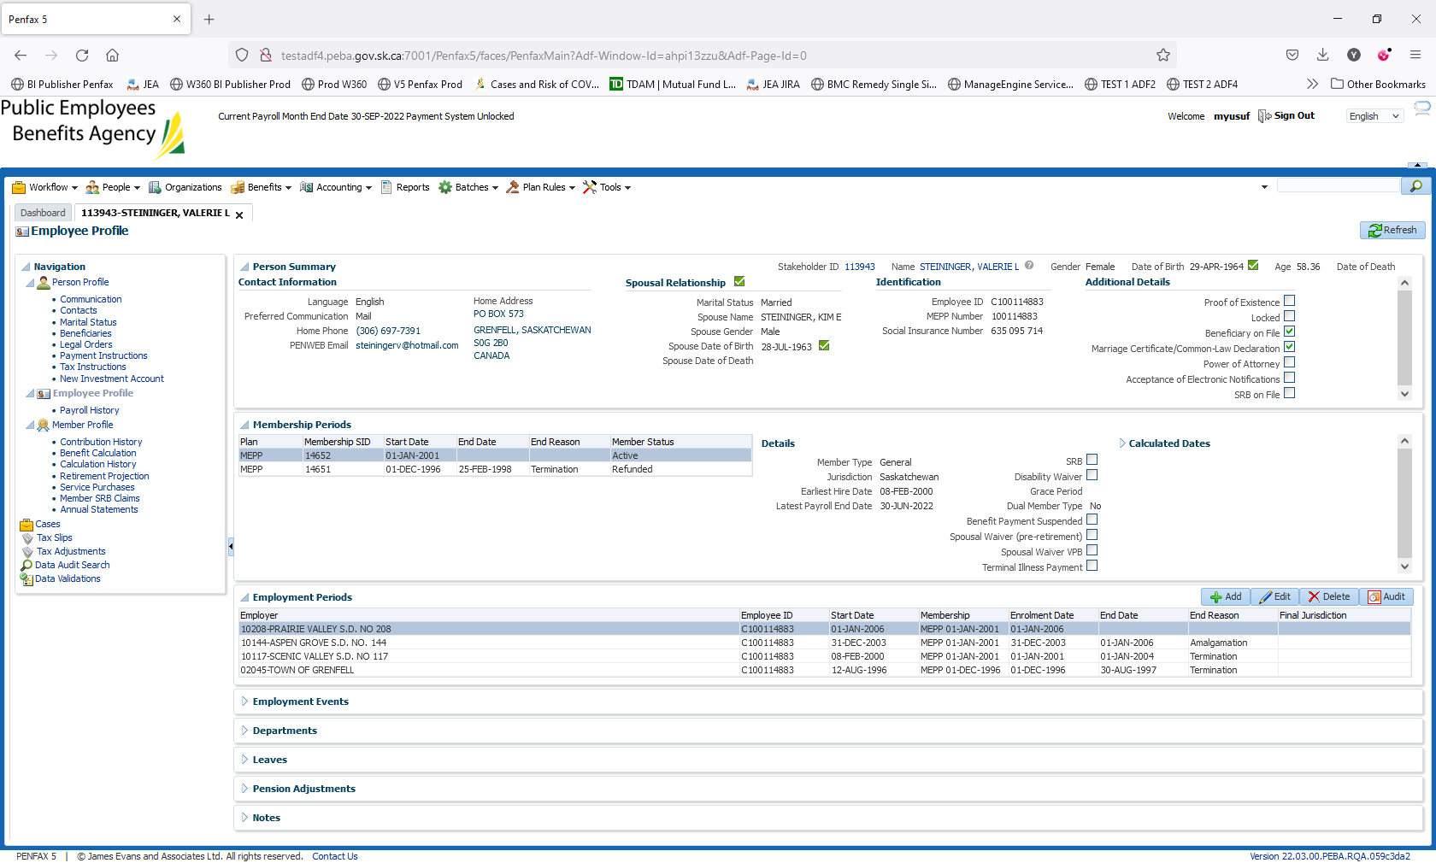

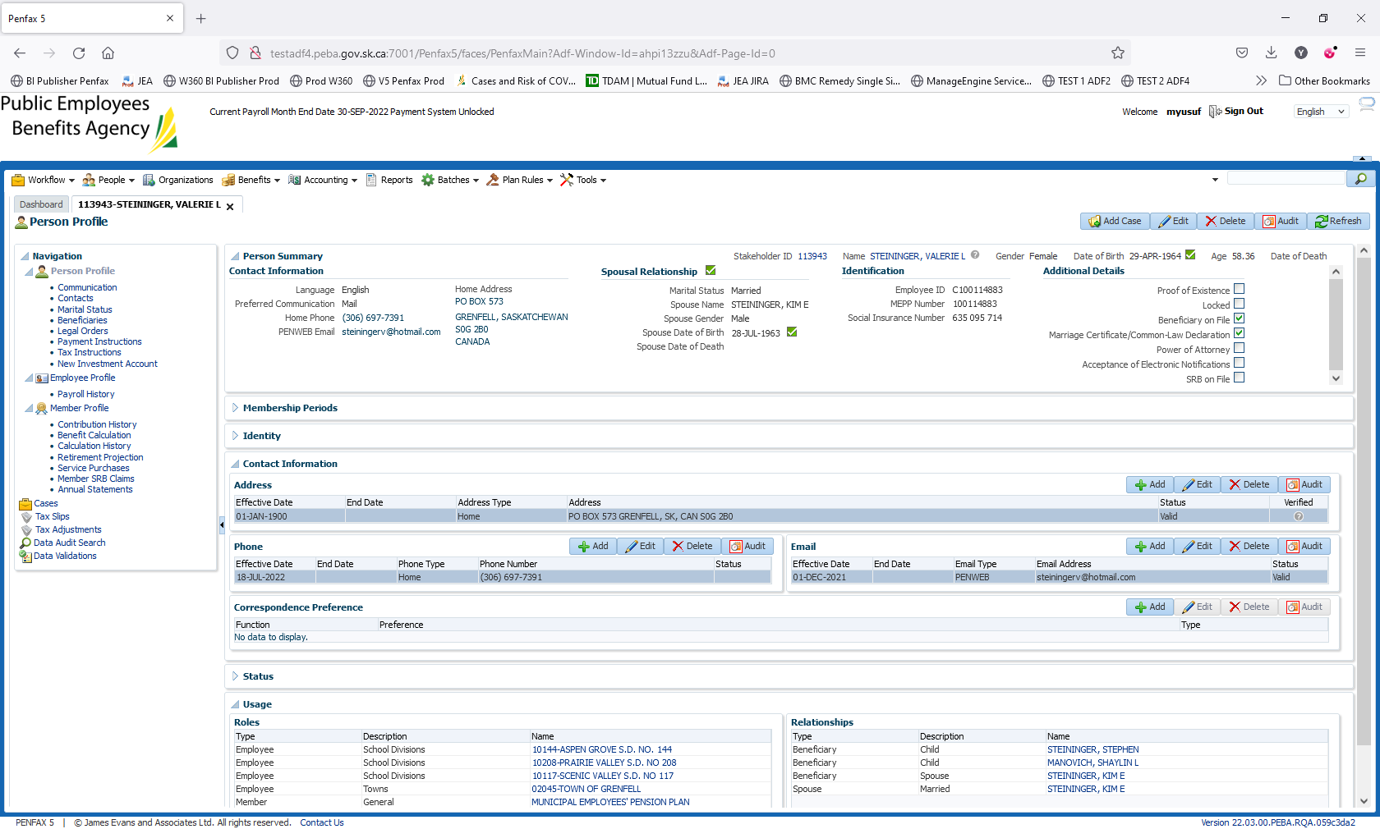

1. Log into MEPP DCT and select the Employer from the dropdown.

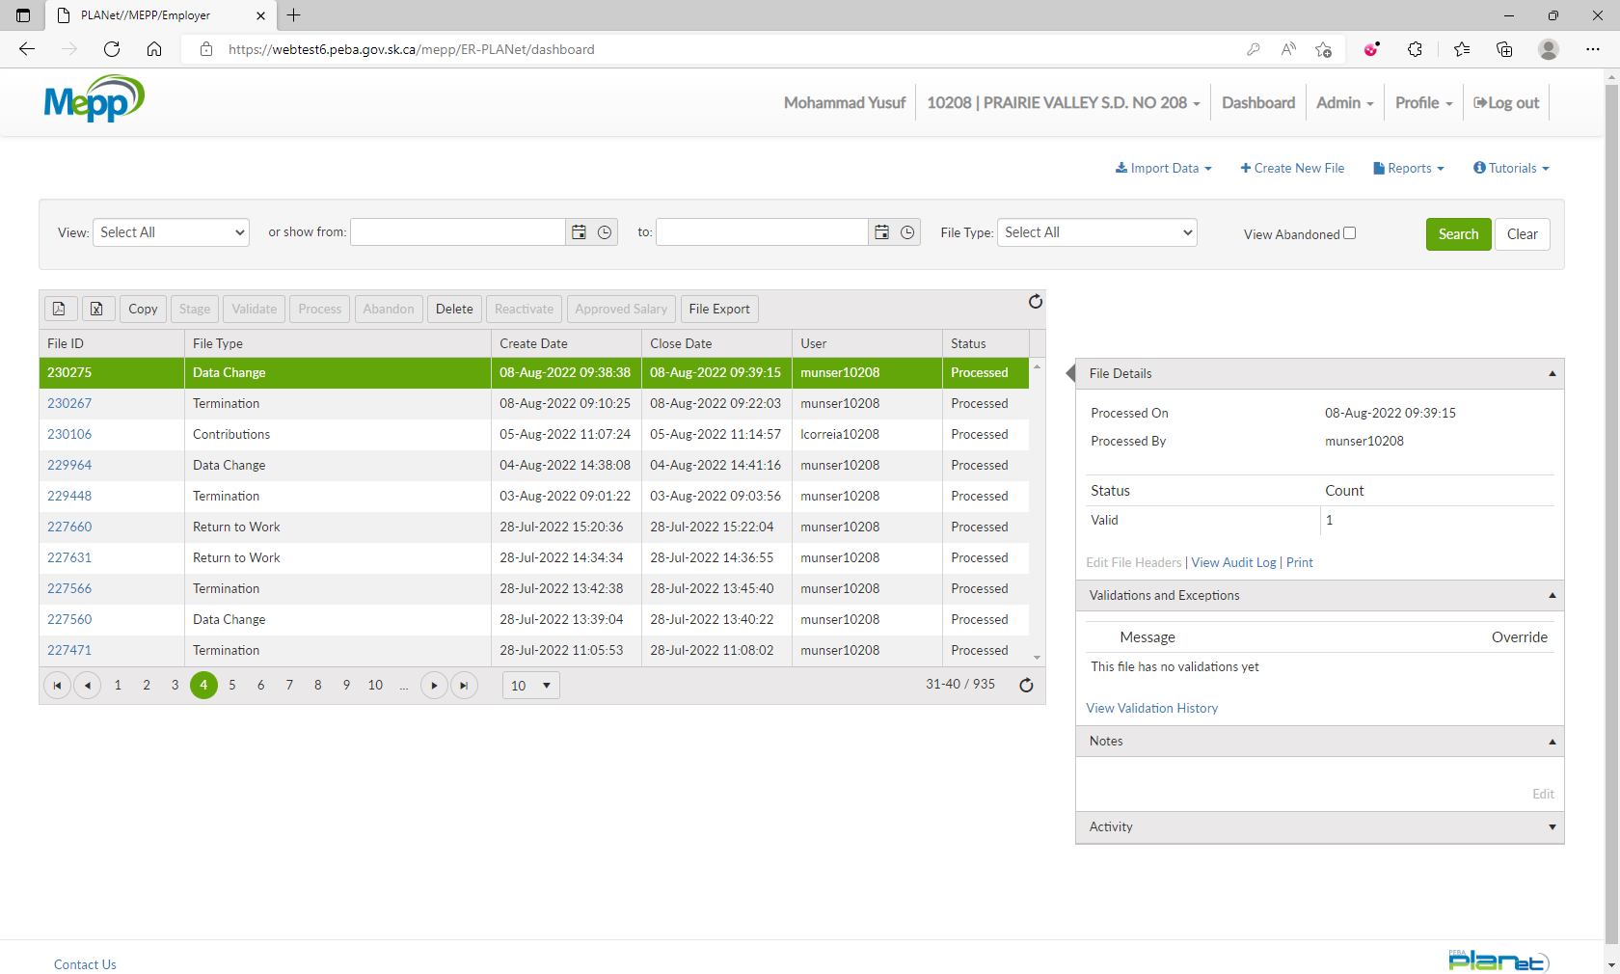

1. Click on Create New File.

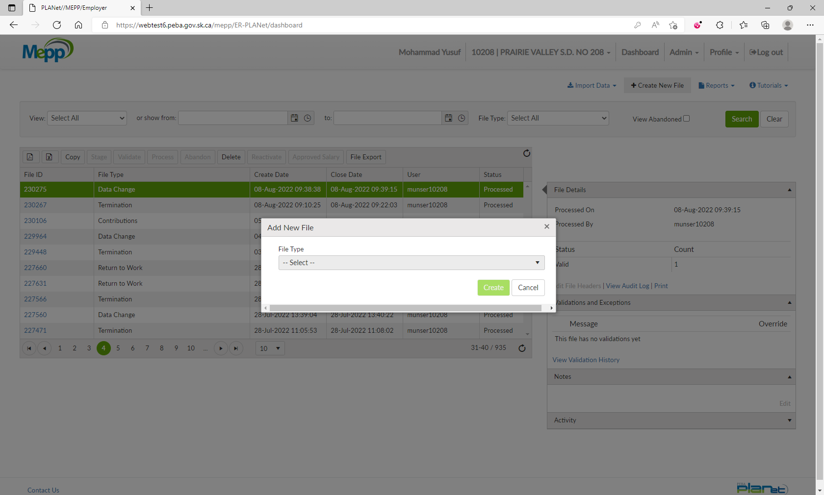

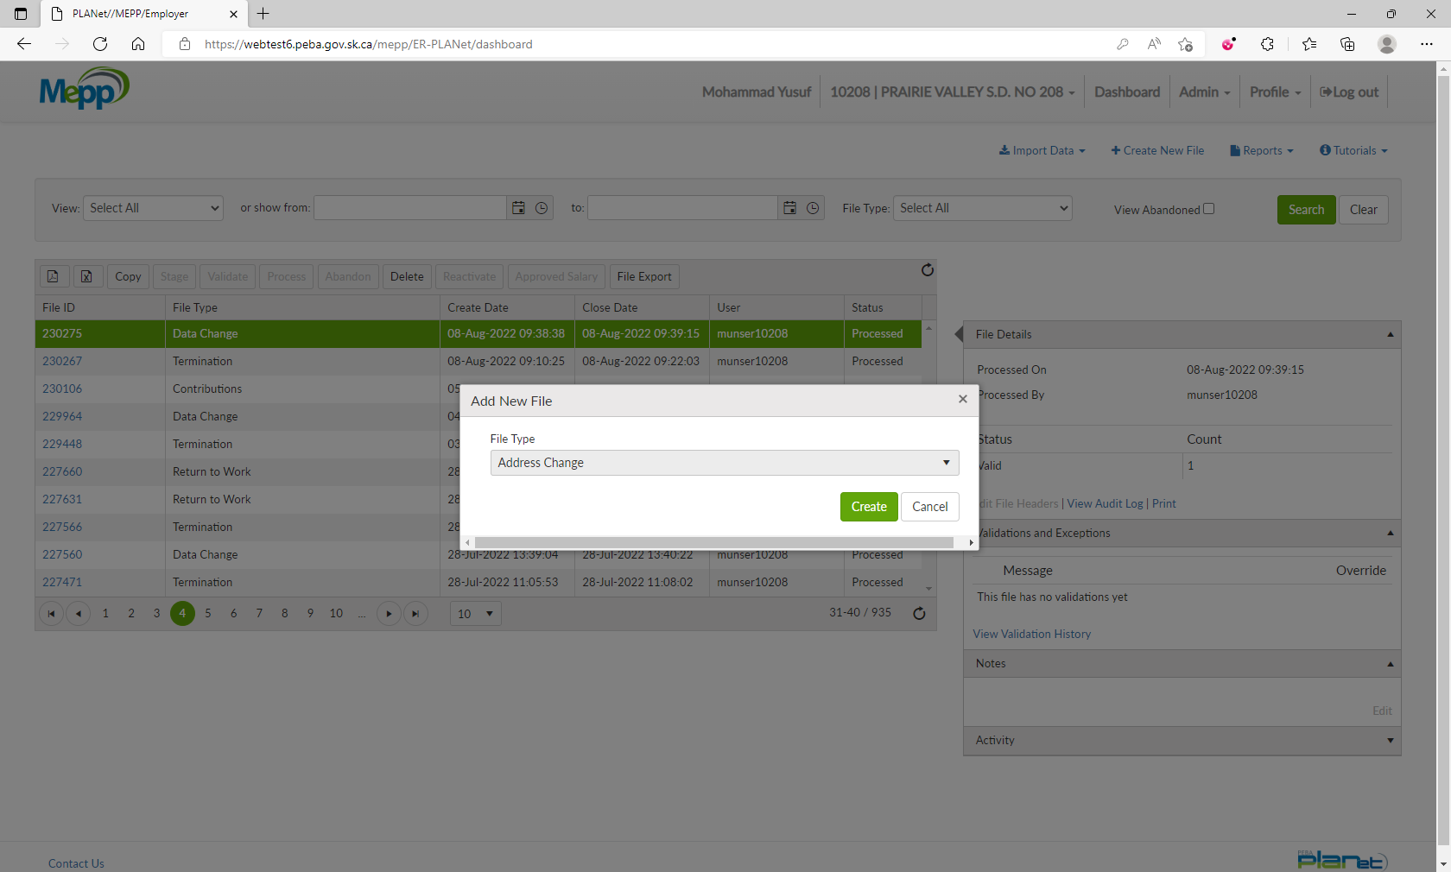

1. Select Address Change from the dropdown and click Create.

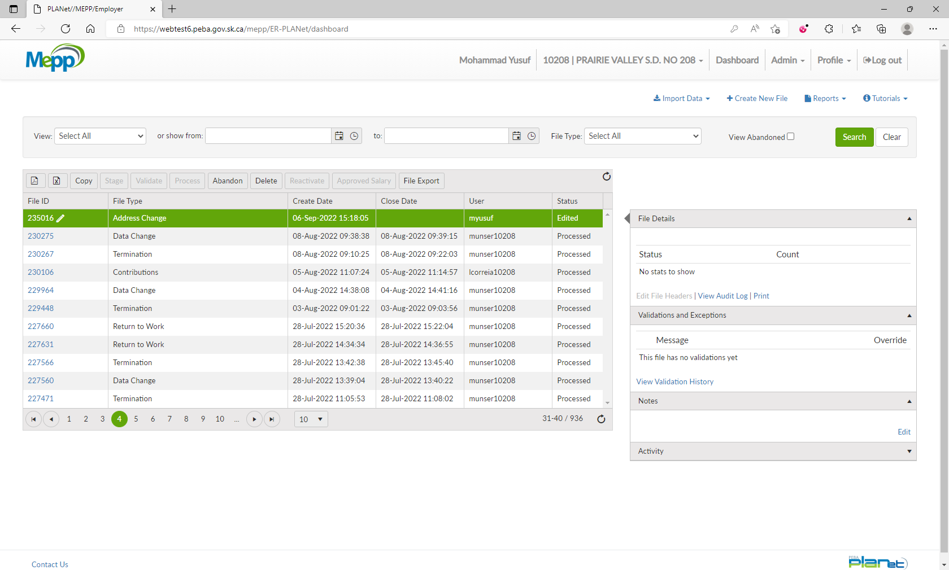

1. Click on File ID to add the transactions.

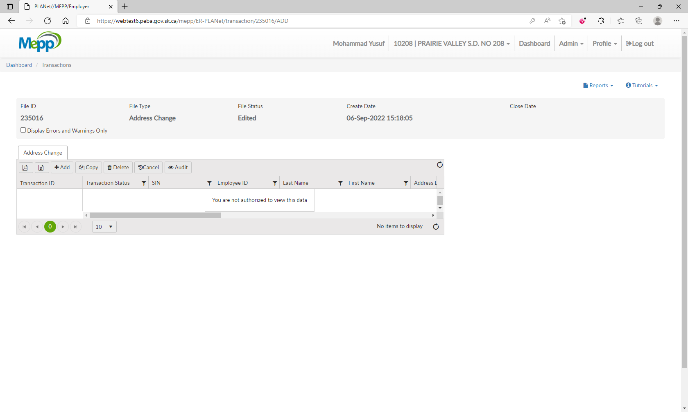

1. Input required details and click Save.

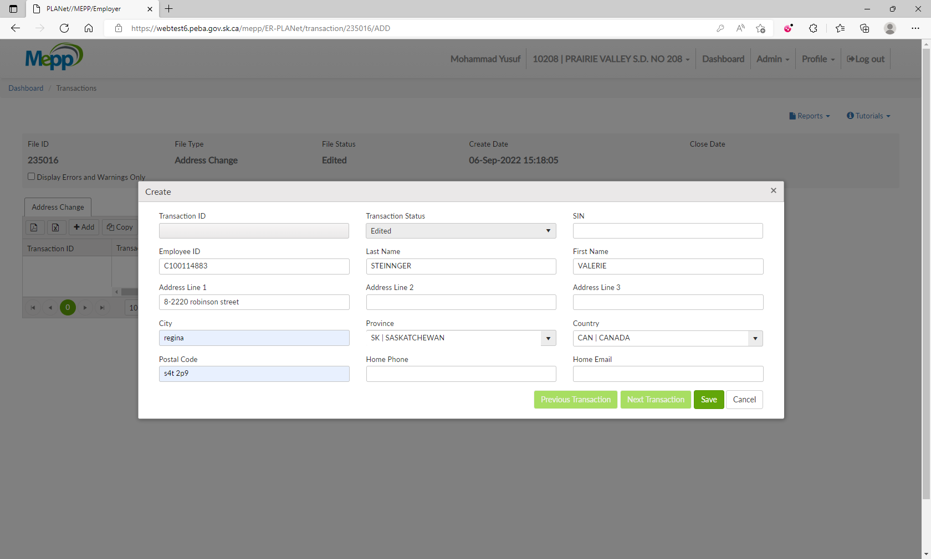

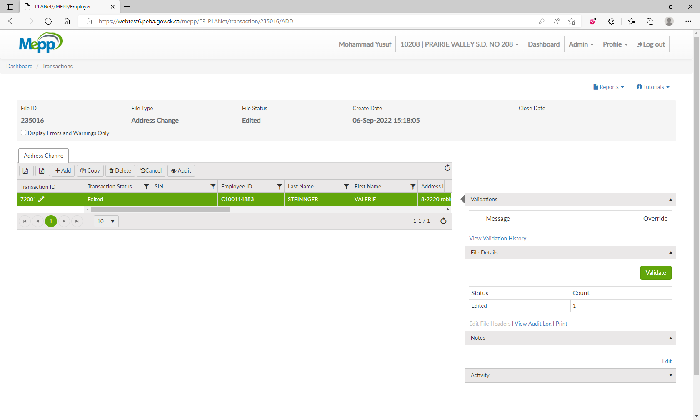

1. Under File Details, click on Validate.

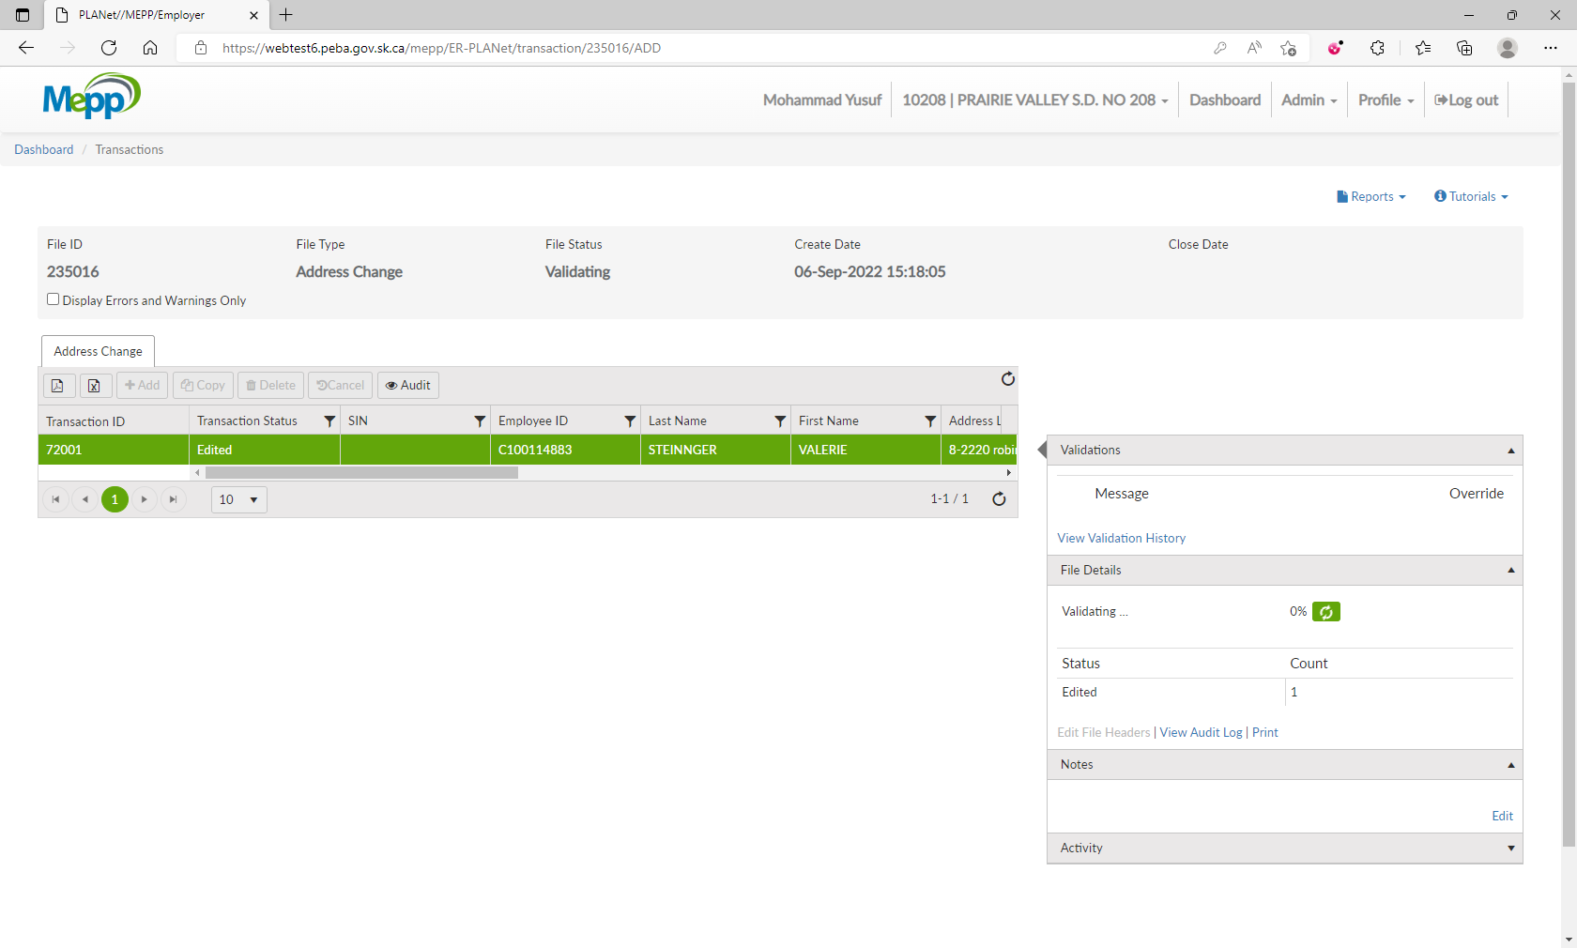

1. Under File Details, click on Process.

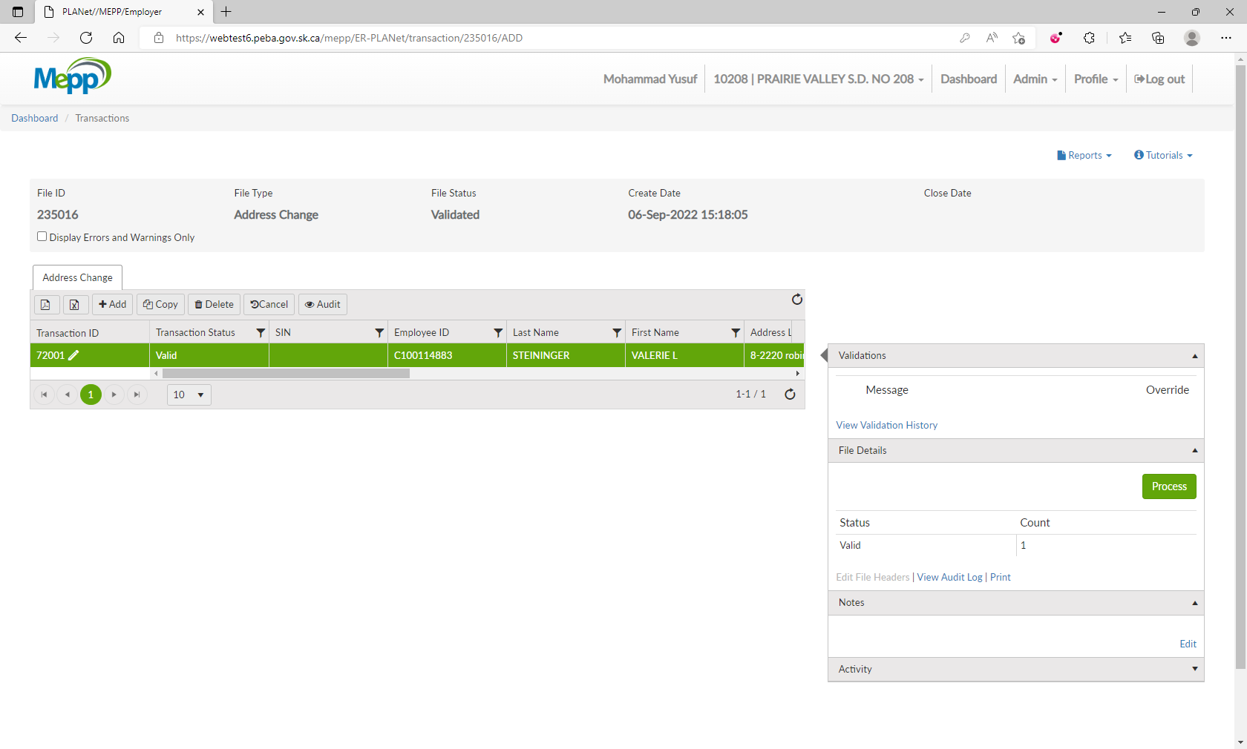

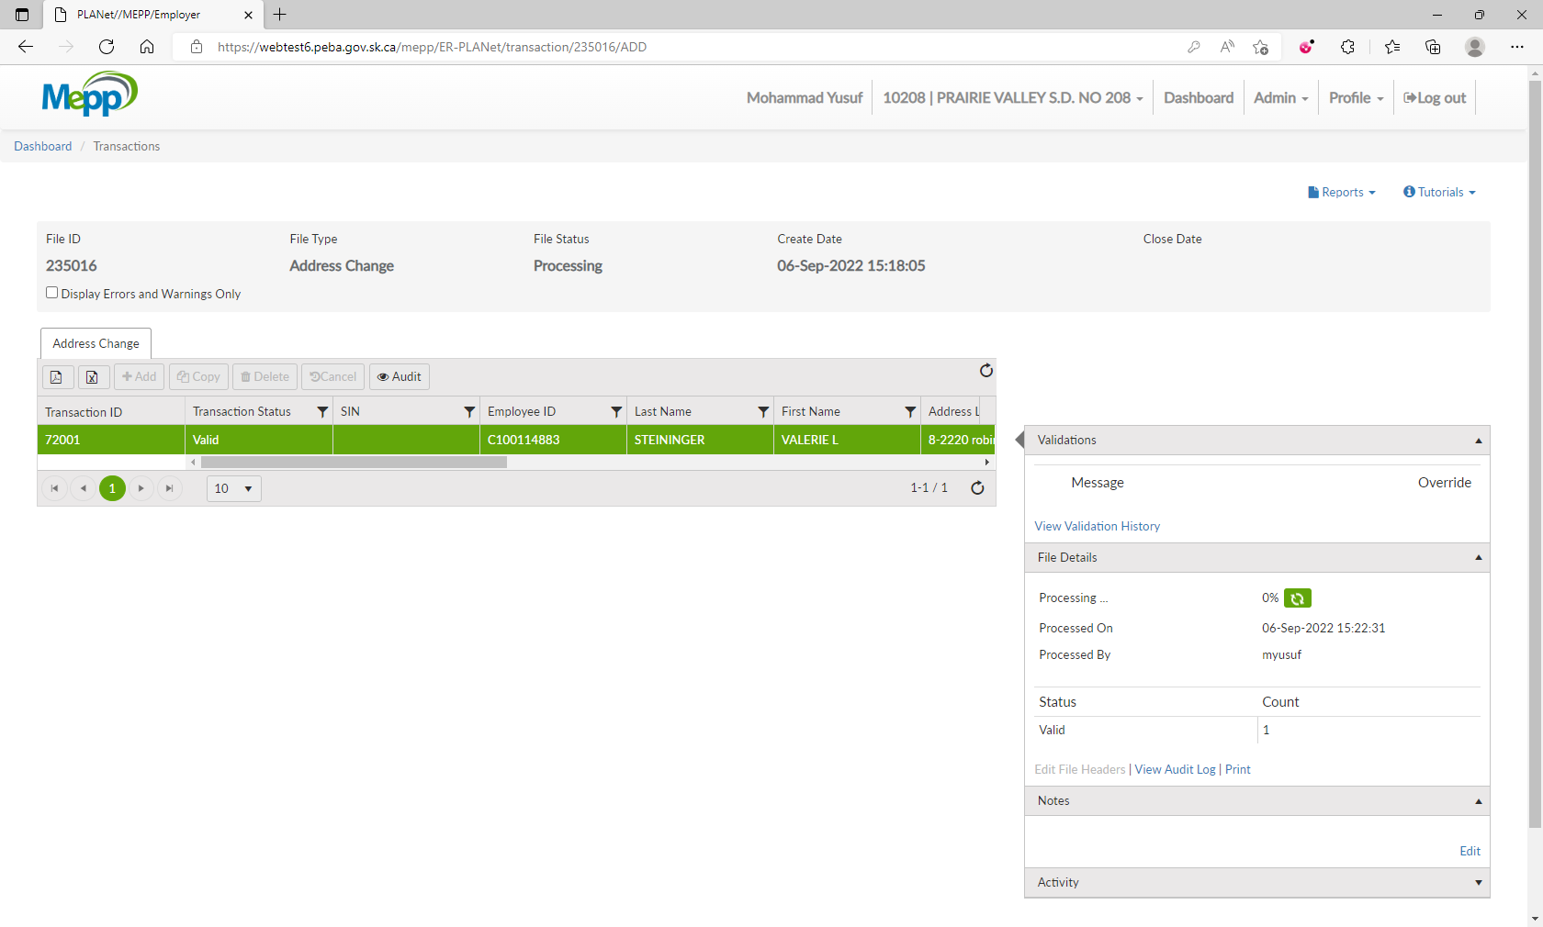

1. File is now processed.

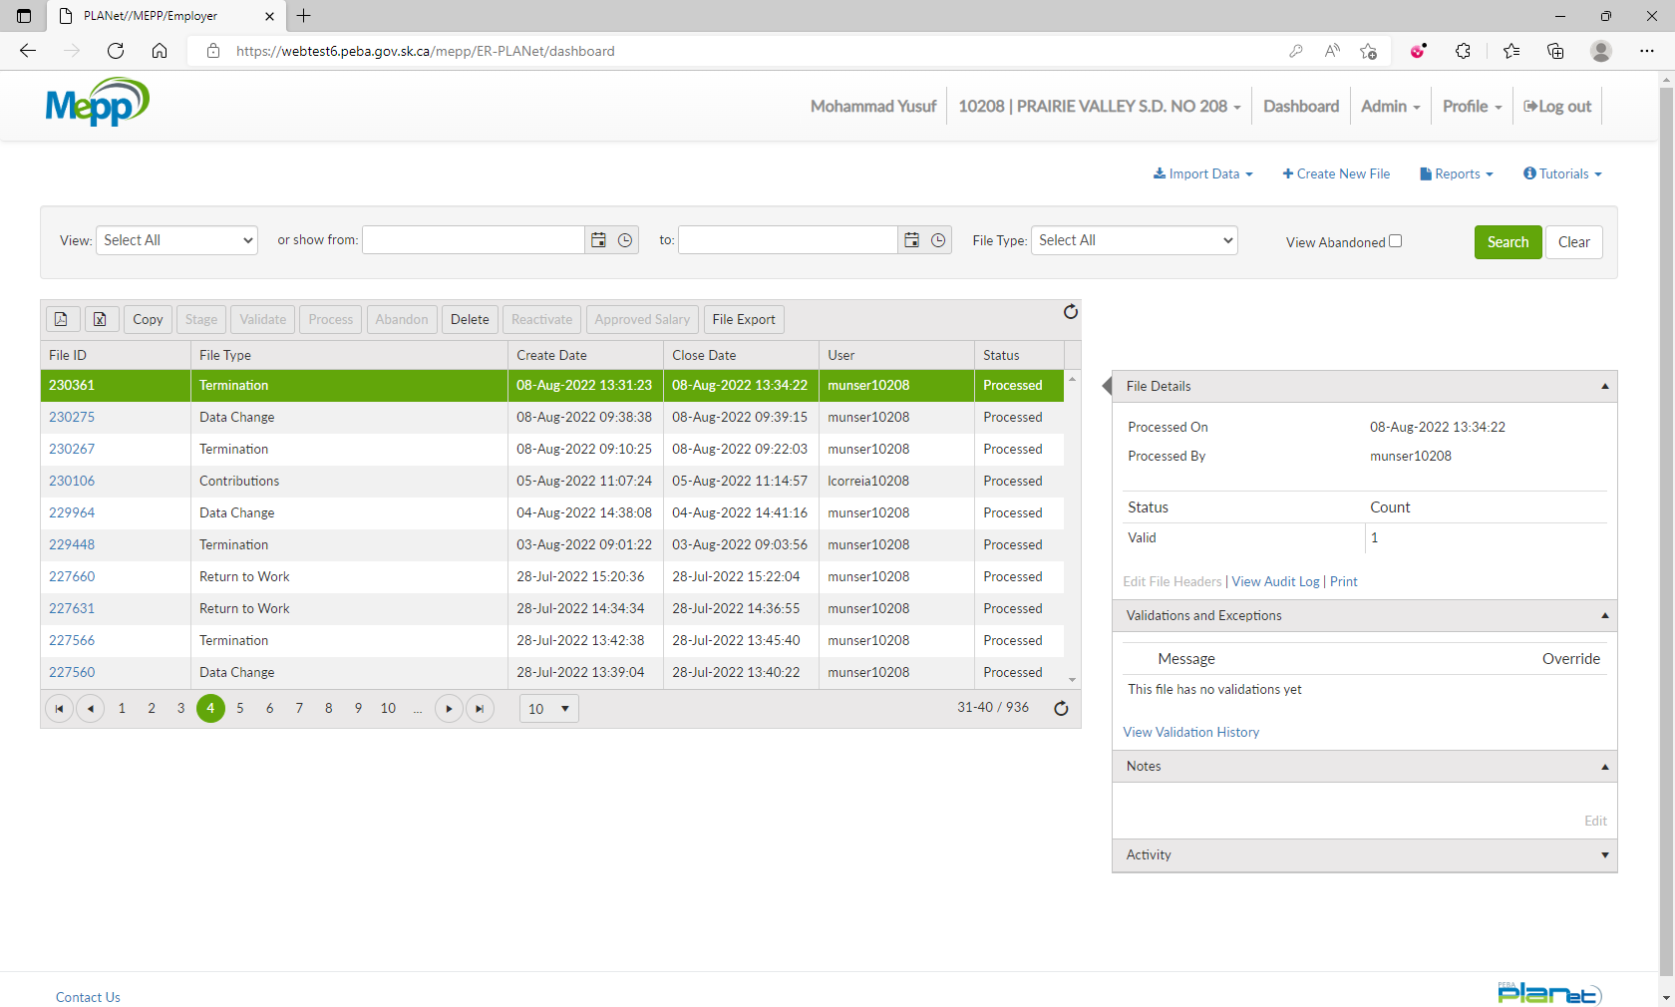

1. Go to Penfax -> Data Posting Batch -> Search by Batch Type and Employer.

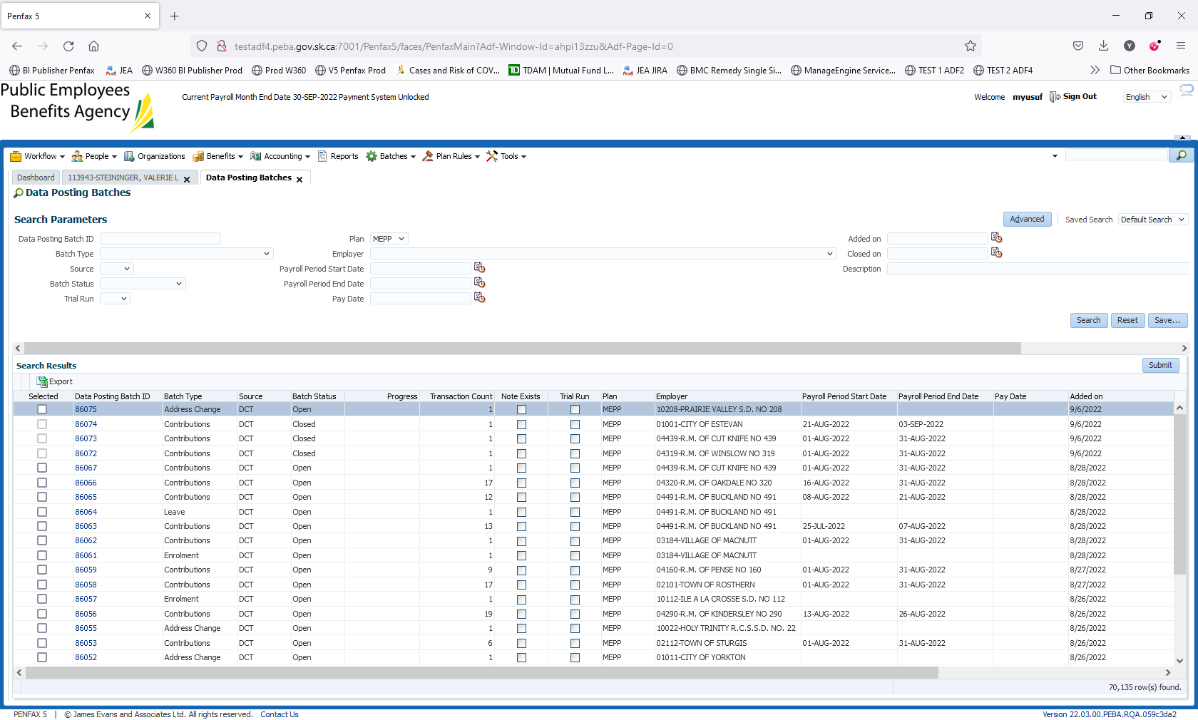

1. Open a batch you just processed through DCT. Go to Pending tab.

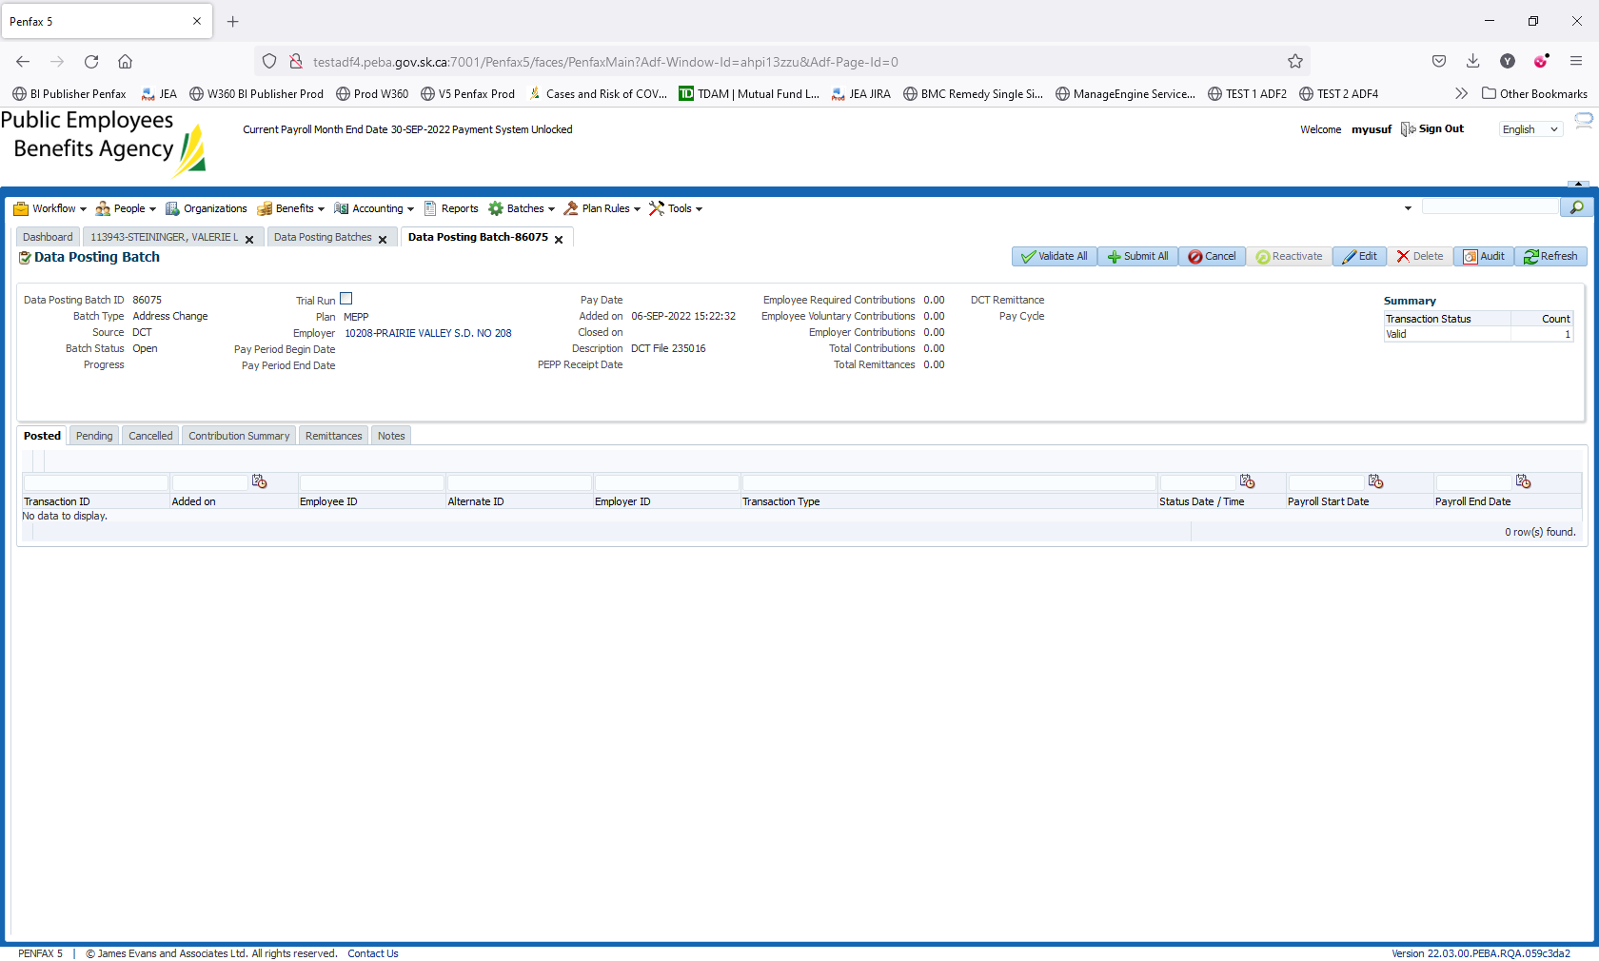

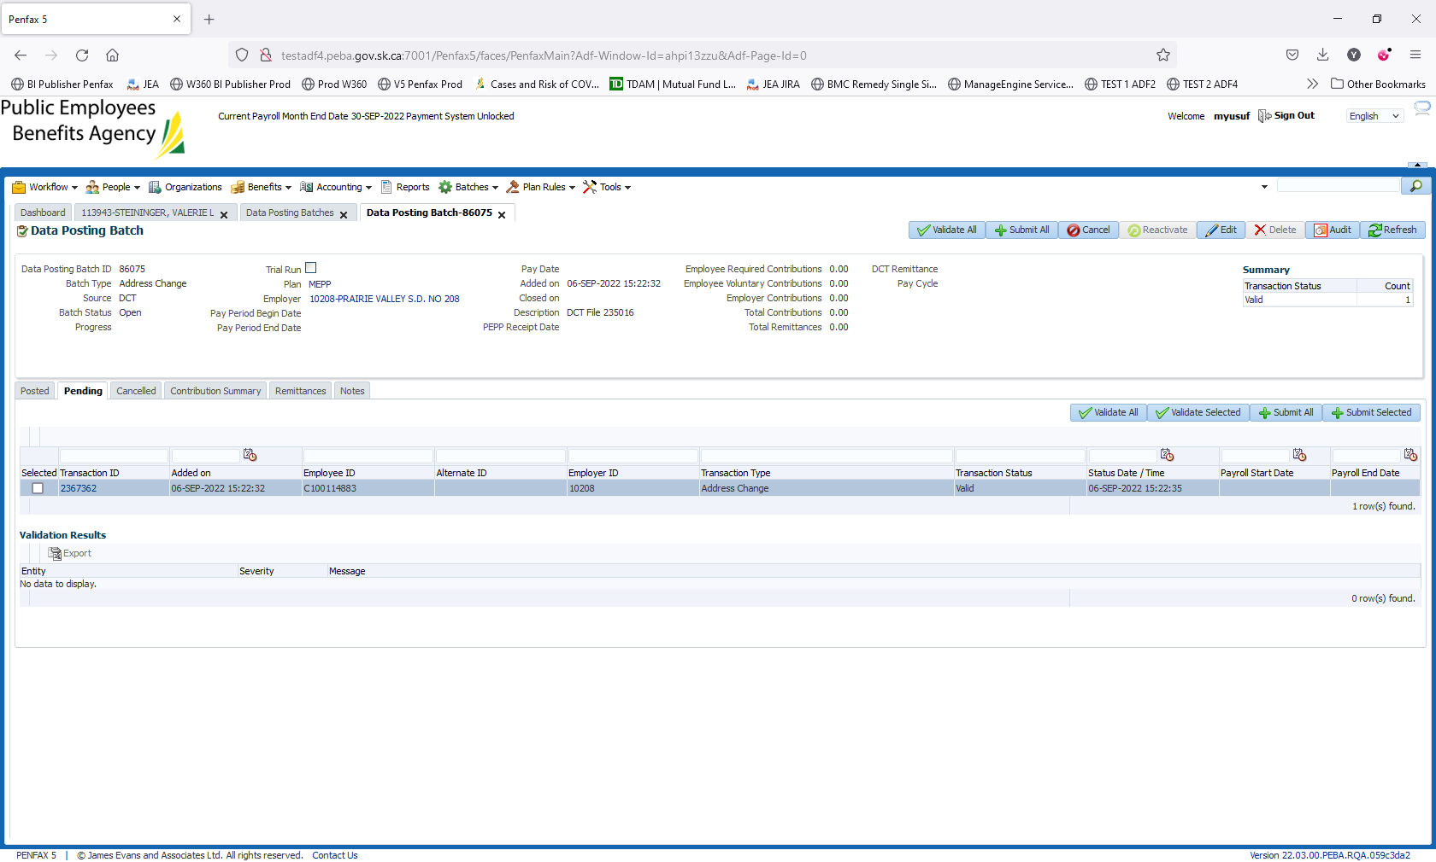

1. Click on Validate All.

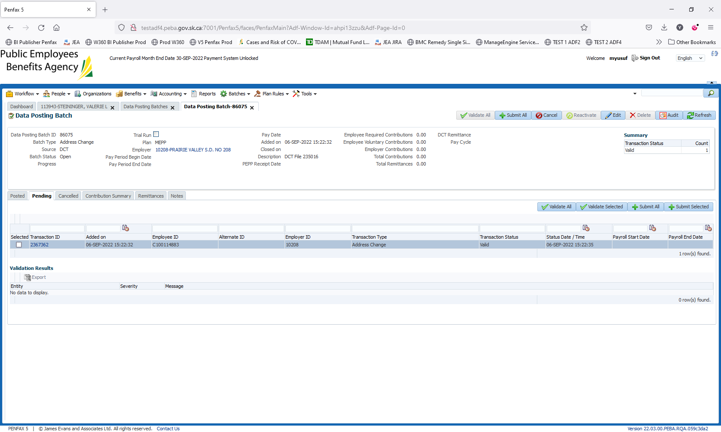

1. Click on Submit All.

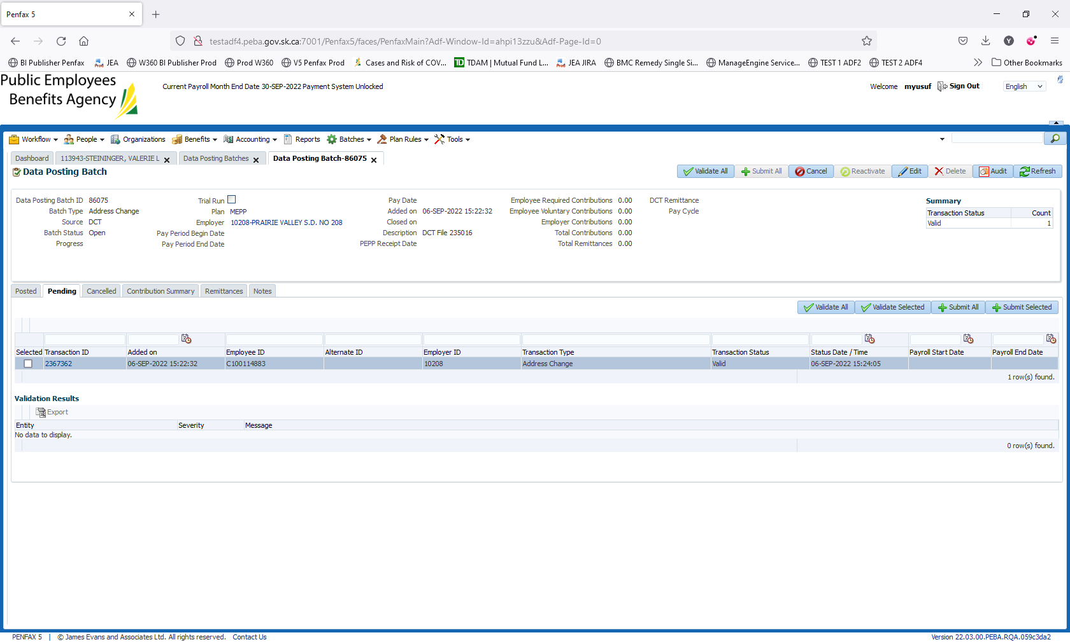

1. Batch is submitted/processed. Transaction is moved to Posted tab. Batch Status is now Closed.

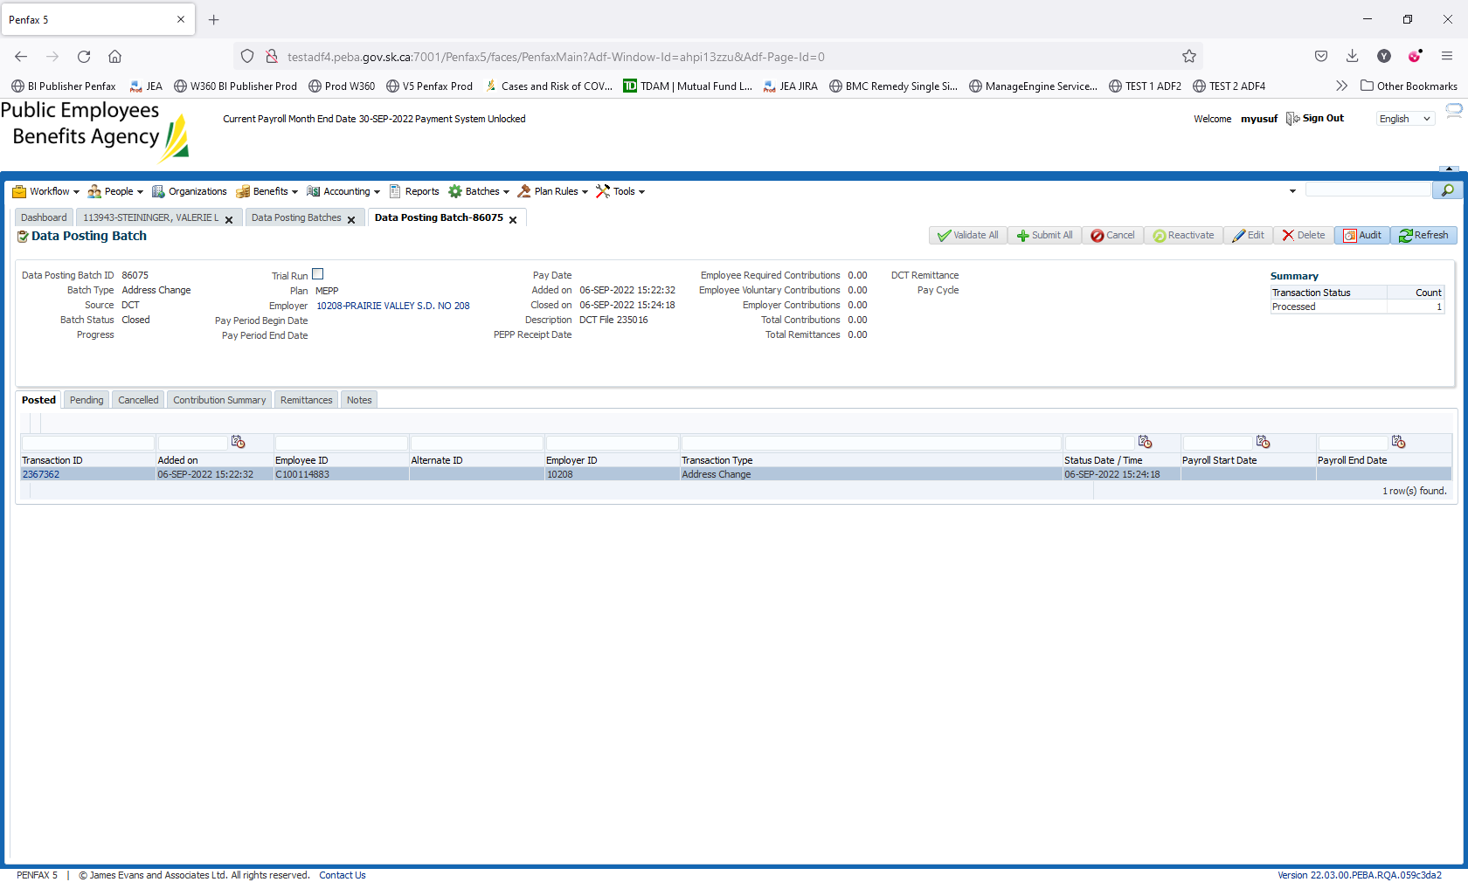

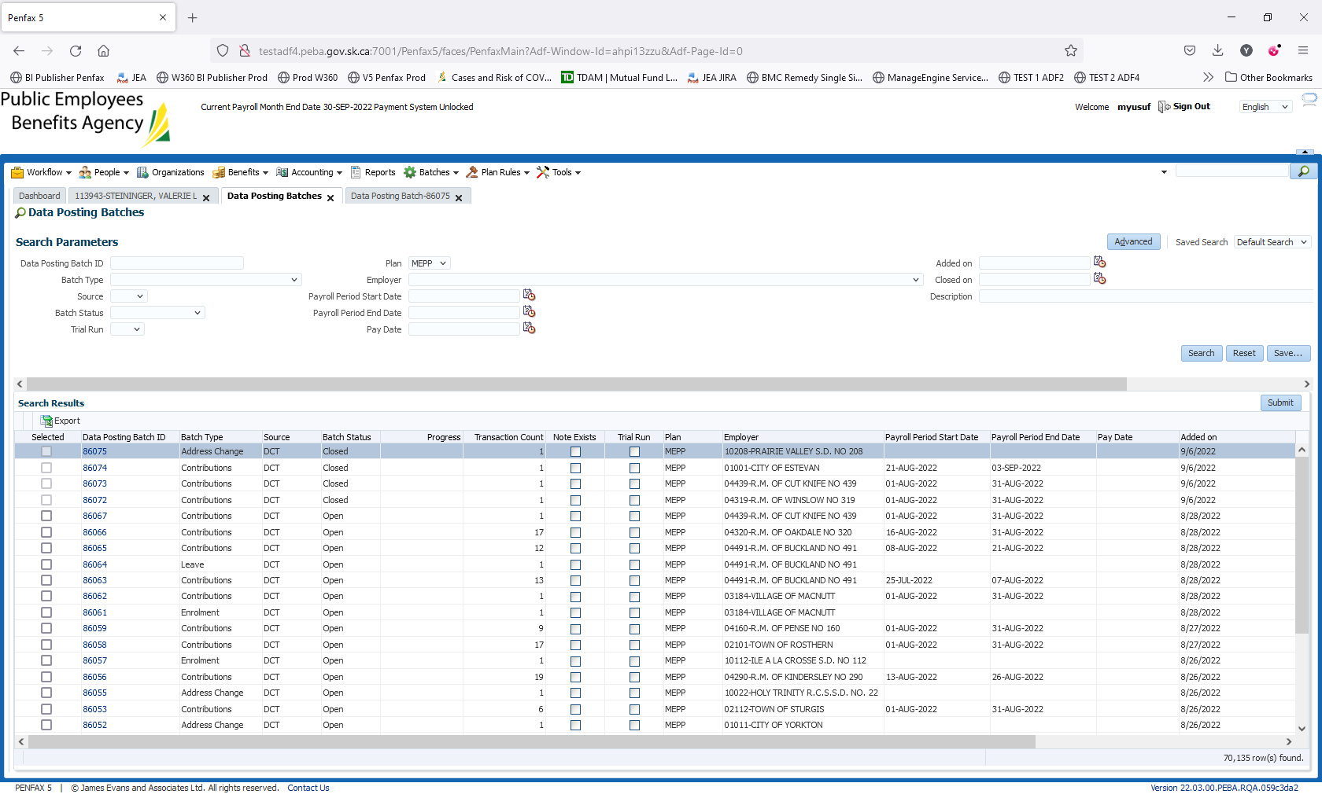

1. Bring up a stakeholder and verify that the home address has been updated under Person Summary and Contact Information.

